**Abbott, Edwin Abbott (1838-1926)**

Edwin Abbott was born in London and educated at the City of London School and St. John’s College, Cambridge. He was ordained in the Church of England in 1863 and returned to the City of London School to serve as its headmaster from 1865-1889. He distinguished himself as a gifted teacher and scholar, publishing fifty-four books on topics ranging from theology and biblical studies to literary criticism and classics. Despite this prodigious scholarly output, Abbott is primarily known today for his single work of fiction, *Flatland: A Romance of Many Dimensions* (1884). This short novel offers both a strident satire of the gender inequities and class divisions of Victorian society and a deft popularization of the mathematics of four-dimensional space. In *Flatland*, a two-dimensional being’s discovery of the third dimension serves as an analogy for the three-dimensional audience’s encounter with a potential fourth dimension.

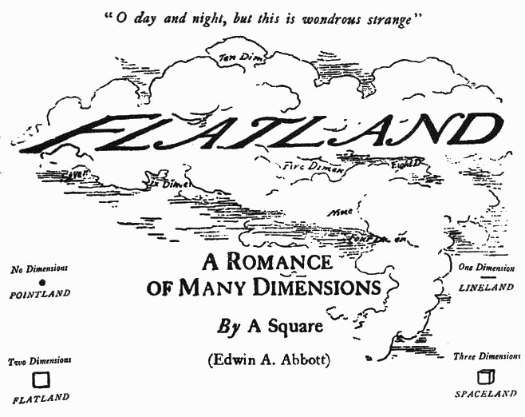

**List of Works**

*A Shakespearian Grammar* (1869)

*Flatland: A Romance of Many Dimensions* (1884)

*Diatessarica* (1900-1917)

**References and Further Reading**

Henderson, Linda Dalrymple. *The Fourth Dimension and Non-Euclidean Geometry in Modern Art*.

Ruker, Rudy. *The Fourth Dimension: Toward a Geometry of Higher Reality*.

Suvin, Darko. *Victorian Science Fiction in the UK*.